MATHEMATICS METHODS

MAWA Semester 1 (Unit 3) Examination 2020
Calculator-free

Marking Key

© MAWA, 2020
Licence Agreement
This examination is Copyright but may be freely used within the school that purchases this licence.
- The items that are contained in this examination are to be used solely in the school for which they are purchased.
- They are not to be shared in any manner with a school which has not purchased their own licence.
- The items and the solutions/marking keys are to be kept confidentially and not copied or made available to anyone who is not a teacher at the school. Teachers may give feedback to students in the form of showing them how the work is marked but students are not to retain a copy of the paper or marking guide until the agreed release date stipulated in the purchasing agreement/licence.

The release date for this exam and marking scheme is
- June 12th the end of week 7 of term 2, 2020

Section One: Calculator-free (50 Marks)

Question 1(a) (2 marks)
Solution
Mathematical behaviours | Mark
- applies chain rule  - obtains correct result | 1  1

Question 1(b) (2 marks)
Solution
Mathematical behaviours | Marks
- differentiates cos term correctly  - applies product rule and states result | 1  1

Question 1(c) (3 marks)
Solution
Mathematical behaviours | Marks
- differentiates correctly  - substitutes and simplifies to (*)  - evaluates correctly, stating Pythagorean identity | 1  1  1

Question 2(a) (2 marks)
Solution
Mathematical behaviours | Marks
- equates function to 0 and obtains  - states | 1  1

Question 2(b) (4 marks)
Solution
Mathematical behaviours | Marks
- differentiates, equates to 0 and solves  - obtains correct $y$ values of the stationary points  - uses second derivative test (or sign test) to determine nature of stationary  points  - locates point of inflection | 1  1  1  1

Question 2(c) (1 mark)
Solution
Mathematical behaviours | Marks
- determines and concludes maximum | 1

Solution
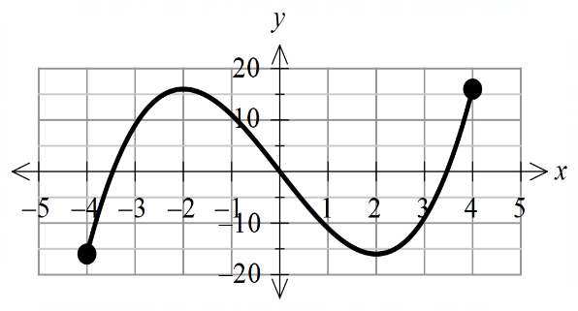
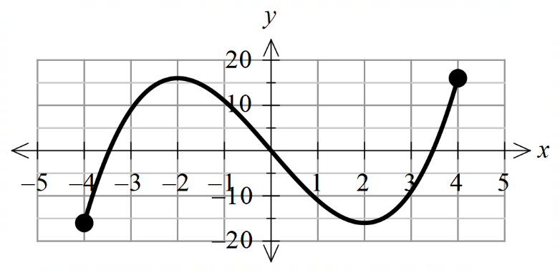


Mathematical behaviours | Marks
- plots zeros at 0 and such that  - plots stationary points and point of inflection accurately  - obtains correct shape for the graph, scale and end points | 1  1  1

Question 2(d) (3 marks)
Question 3(a) (1 mark)
Solution
,
Mathematical behaviours | Mark
- states correct answer | 1

Question 3(b) (4 marks)
Solution
Mathematical behaviours | Marks
- states the change as  - anti-differentiates correctly  - substitutes correct limits of integration  - determines correct answer | 1  1  1  1

Question 4(a) (2 marks)
Solution
Mathematical behaviours | Marks
- states the sum of probabilities is 1  - deduces k value | 1  1

Question 4(b) (2 marks)
Solution
Mathematical behaviours | Marks
- states an expression to calculate required probability  - determines probability | 1  1

Question 4(c) (2 marks)
Solution
Mathematical behaviours | Marks
- writes fraction with the correct denominator  - obtains simplified result | 1  1

Question 5(a) (4 marks)
Solution
(i)

(ii)

Mathematical behaviours | Marks
(i)  - states anti-derivative  - evaluates result  (ii)  - rewrites fraction as sum of two functions  - anit-differentiates including | 1  1  1  1

Question 5(b) (3 marks)
Solution
(i)
(ii)
Mathematical behaviours | Marks
(i)  - applies linearity of integrals, swaps bounds of integration and determines the correct result  (ii)  - applies linearity of integrals correctly  - integrates correctly and calculates the result | 1  1  1

Question 5(c) (5 marks)
Solution
Mathematical behaviours | Marks
- applies the chain rule to the derivative  - differentiates correctly  - recognises application of the Fundamental Theorem  - factors out and re-writes fraction involving in numerator and denominator as one fraction squared  - multiplies both sides of expression by to obtain desired result | 1  1  1  1  1

Question 6(a) (3 marks)
Solution
Mathematical behaviours | Marks
- applies quotient rule  - differentiates both parts correctly and states the value of c and d  - simplifies result and states value of a and b | 1  1  1

Question 6(b) (2 marks)
Solution
So the coordinates of B are
Mathematical behaviours | Marks
- equates derivative to 0 and solves  - states co-ordinates of B | 1  1

Solution
It is the area between the two curves from x = 0 to x = π.
Mathematical behaviours | Marks
- states it is the area between the two given curves  - states the area is from to | 1  1
Question 7(a) (2 marks)

Question 7(b) (3 marks)
Solution
Mathematical behaviours | Marks
- anti-differentiates correctly  - anti-differentiates correctly  - includes constant of integration | 1  1  1

